Vehicle Maintenance Management

**Vehicle Conditions Checking Activity Diagram**

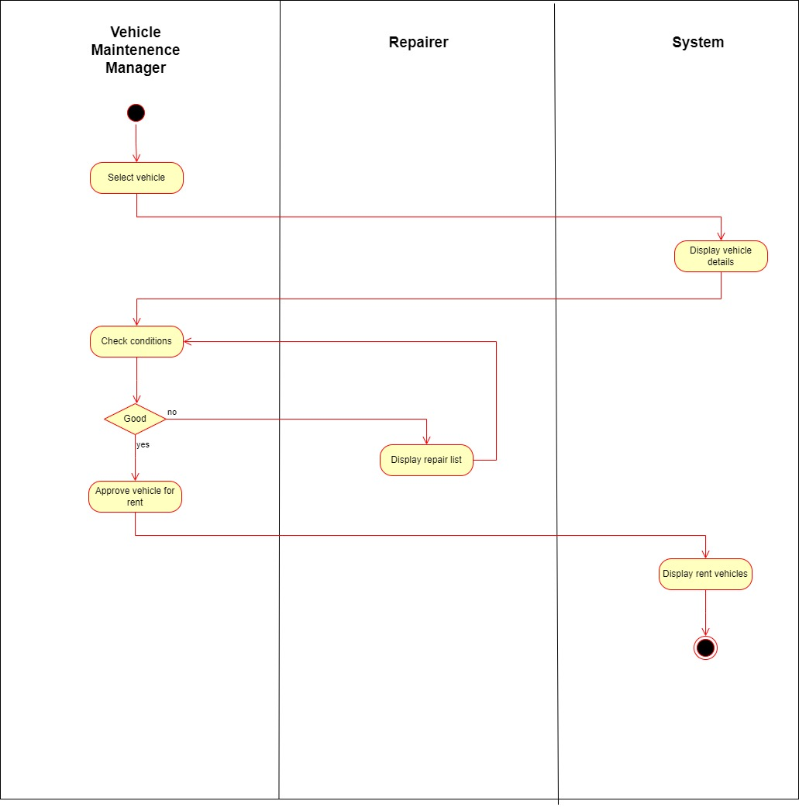

**Repairing Activity Diagram**

Sequence Diagram